Non‐IU Health Research Access Request FAQ
All research persons requesting access to IU Health Systems must first complete a paper Research Access Request form and sign the Responsibility Statement/Data Stewardship Agreement. Requests must include a current IRB Approval Letter with IRB# and Principal Investigator’s name.

Submitting the Requests

  - All information must be complete and legible. Incomplete/illegible forms will be returned.

- All forms must be scanned and emailed to helpdesk@iuhealth.org.

  - All personal information is kept in accordance with IU Health Privacy Policies.

IU Health Approval

Requests must be approved by an IU Health Credentialed Physician (who may also be the Principal Investigator), IU Health Manager, or IU Health Director.

Access Support

If you need assistance with requesting access to Cerner after reviewing this FAQ, please contact Cheryl Yacone at (317) 963-0545 or cyacone@iuhealth.org

The IU Health IS Service Desk can assist with password resets and other issues by calling 317‐962‐2828.

Access Expiration

Your access expires annually on March 1st. Renewals require a new paper request form, a Responsibility Statement/Data Stewardship Agreement, and a copy of a current IRB approval letter. Please note you will not receive notification that your access is expiring ahead of time. It is your responsibility to keep track of the expiration date and request access in advance.

Removing Access

If someone leaves your organization or their job changes, their IU Health access must be removed/updated. Please notify the IU Health IS Service Desk at 317‐962‐2828 as soon as you are aware that an individual no longer should be able to access the system.

Tips on Completing the Request Form

New access requests require submission of the following documents:

- Completed and signed Paper Research Access Request form
- Signed Responsibility Statement/Data Stewardship Agreement
- Current IRB Approval Letter- only 1 approval letter needs to be submitted

If you have current Cerner access in a clinical patient care position and need to retain that position for use outside of research activities, please check the box indicating that you want to use self-service.

Renewal access requests require the submission of the same paperwork. Your renewal will be at the same level of access you currently have UNLESS you complete section 2 requesting a change to the level of access.

Section 1

Name:

Must be your legal name
Credentials/Title: RN, MD, or NP for example

Last 5 SSN:

Last 5 digits of your social security number*

DOB: MM/DD/YY

Department: Name of department you work with, e.g. Radiology, Surgery, etc.

Phone Number: Office phone number

Email Address: Work email address

IRB Number: IRB number that matches your IRB approval letter

PI: Principal Investigator’s Name

*Required in lieu of an IU Health employee number

Section 2

Complete this section to add new access or to change existing access only.

Access Requested: All users will receive an IUH Windows login (NT login.)

Cerner Access: Select the Cerner access needed. Use the decision tree on the next page to determine the correct position to request.

Research access is restricted: no access to Pulse, VPN, or IU Health E-mail.

Section 3

All requests require an approval signature. The signatory must be an IU Health credentialed physician
or an IU Health Manager/Director. Check the box indicating which type of signatory is approving the access.

All fields must be completed and information entered must be legible or the form will be returned.

Scan the completed forms with the required attachments and e-mail to your forms to
Helpdesk@iuhealth.org.

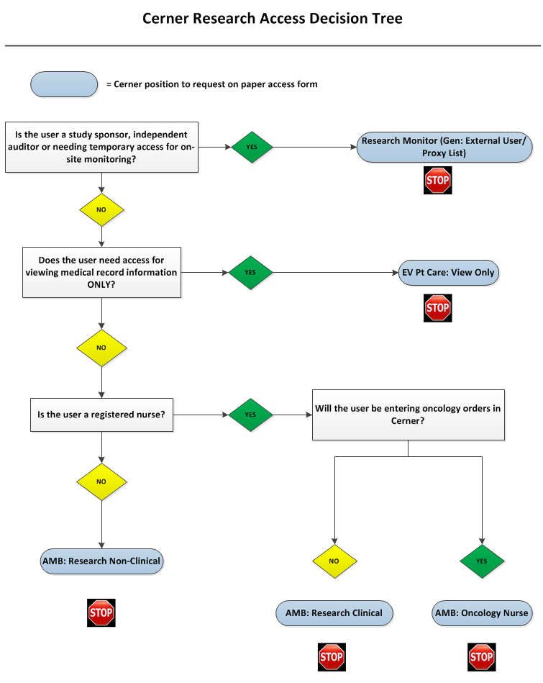

IMPORTANT INFORMATION---PLEASE READ!
Requesting access to one of the research positions that begin with AMB will change the look of your electronic medical record view in Cerner PowerChart. The application will open to Message Center. You can access your patient lists and tracking shells from the links in the second line of the menu bar.
If you currently have access to scheduling books, you will want to make a note of which clinics and/or physicians you have. Individual scheduling book access is controlled and once you are put into the new research position, although you will still have access to Cerner Scheduling, you may lose access to your specific provider or groups scheduling books. Please email the IUH help desk (helpdesk@iuhealth.org) with the following verbiage in order to expedite getting the access to needed clinic or physician schedules:
Please log a ticket to the Cerner Scheduling team. I’ve recently had a Cerner position change and can no longer see scheduling views for “INSERT FULL PROVIDER or Multiple Provider NAMES HERE.”

