Topic: Research Related Systems Access  Facility: All IU Health Locations  Audience: Researcher Staff |  | Effective Date  October 21, 2019  Contact  IUHealthResearchAccess@iuhealth.org
Overview: | This job aid outlines the steps to take for new access requests, changes to existing access, or inactivations of all systems access for research purposes.

KEY POINTS

- All individuals requesting access to the Cerner electronic medical record (EMR) for research purposes are expected to understand and follow all applicable IU Health policies as well as applicable HIPAA guidelines and regulations.
- All research related access to the EMR must be performed under the auspices of an Institutional Review Board. Proof of current IRB approval or exemption will be requested.
- The Clinical Research Systems Team must be notified immediately when individuals with research related access are no longer performing research related activities.
- Access is granted based on the available Cerner position that best fits your needs. Some positions are setup with access that may exceed your job description and/or professional practice standards. You are responsible for accessing the system within the parameters established by your job description.
- All non-IU Health employees requesting access will be given a Lawson account with an IU Health NT logon and applicable active directory groups.
- Per policy HR-142 section VI. C. 3- Non-Indiana University Health team members must complete the computer-based modules via electronic learning management system (eLMS) for all mandatory curricula for regulatory compliance. All non-IU Health employees requesting access will be required to complete the following 6 educational modules to obtain/maintain access to IU Health systems-
  - Corporate Compliance
  - Environment of Care
  - HIPAA
  - Patient Safety
  - Information Security HIPAA
  - Infection Prevention
- With certain exceptions, research access will not expire once granted. You will no longer need to submit annual requests for renewal.
- The CRS team will be performing a cross-institution employment/student validations as well as periodic reviews for current IRB approvals.
- All access to the system is monitored by Haystack to ensure that access to patient records is limited to those with a legitimate business need.

REQUESTING ACCESS- NON-IU HEALTH EMPLOYEES

- Research staff with a business need to access the Cerner EMR can begin the request process by completing the REDCap survey found at the following link- https://redcap.uits.iu.edu/surveys/?s=AC7JXK9XEY.
Requesters will be asked to provide the name and phone number for their supervisor/manager in the event that follow-up is needed and a copy of one of the current IRB approval/exemption letters for their studies. This link can also be used to request a change to access or demographic information such as a change in research department.
- The survey is automatically forwarded to the Clinical Research Systems team for review and approval.
- Once approved, the requester will receive an e-mail from the CRS team with the following-
  - Select IU Health policies related to research activities
  - Research Related Systems Access Job Aid
  - NT/Cerner user name and temporary password
  - Links for accessing the annual mandatory education modules
    - Corporate Compliance
    - Environment of Care
    - HIPAA
    - Patient Safety
    - Information Security HIPAA
    - Infection Prevention
- Research staff will have 14 days to complete the mandatory on-line training required and confirm training using the REDCap survey provided with the module links.
- See the “Accessing Cerner” section of this job aid for instructions on how to access the Cerner electronic medical record.

REQUESTING ACCESS- IU HEALTH EMPLOYEES

- IU Health employees needing access to systems for research purposes should complete a SOLAR by clicking on the following link- https://iuhservicemanager.iuhealth.org/CherwellPortal/IUH%20Home?Locale=en-US&_=24e54f03#0
- Click on the “Submit a SOLAR” link.
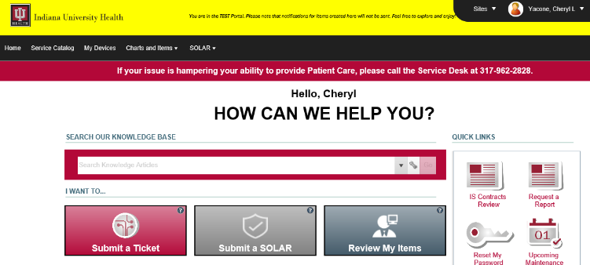

- Click on the” Create a New SOLAR” button.
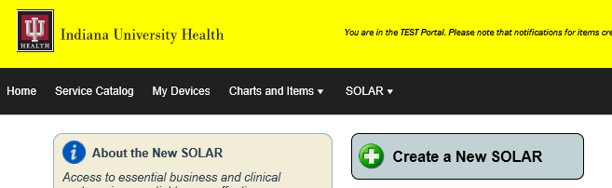

- Sign the SOLAR Data Stewardship Agreement.
- Select the “Cerner” option and then Select “Clinical Research”
- Complete/Verify the contact information and complete the business justification section. Then click “Next”.

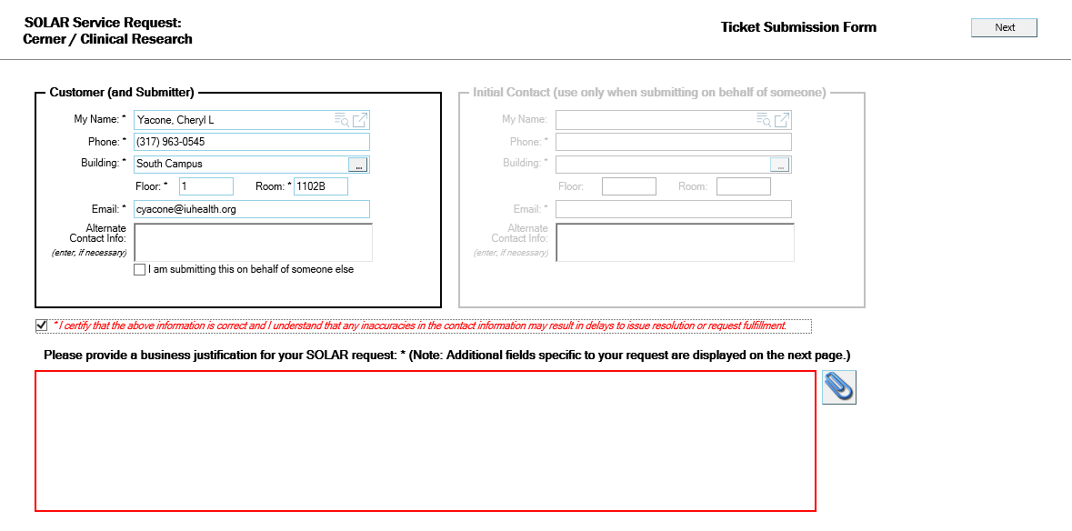

- Pick either “Add Access” for new or changed access or “Remove Existing Access” to inactivate access.
- Select one of the following positions.
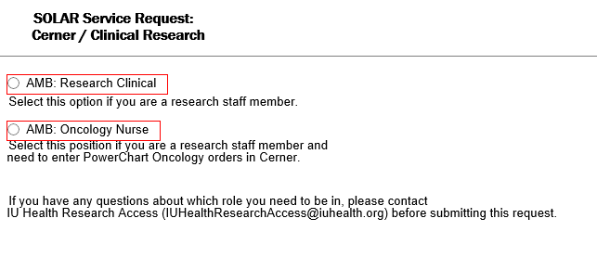

- Once selected, click “Add to Cart”

- Submit your ticket by clicking on “Submit Order”
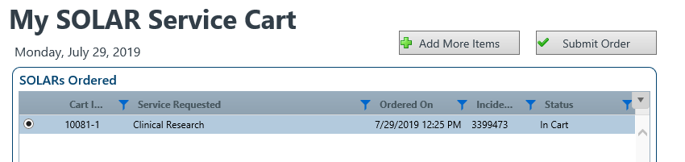

- The request will be approved by your manager and by the Clinical Research Systems team.

MEDICAL STUDENTS

Academic affairs is responsible for managing short term access to the system for research purposes. Send e-mail request to docs@iuhealth.org. Medical students with existing system access must request research view only access and use Cerner self-service to switch to the research role when accessing a medical record for research purposes.

Access to other IS Systems for Research Purposes i.e. Synapse, PACS

The individual needing access to other IS systems such as Synapse or PACS for research purposes should use the SOLAR process available at the following link-
https://iuhservicemanager.iuhealth.org/CherwellPortal/winlogin

Requesters will need their NT logon and password to use SOLAR. If you do not have a NT logon yet, the IU Health manager responsible for overseeing your access will need to complete the “Non-Employee Activate-Inactivate Lawson Form” available on the IU Health Team Portal first.

CHANGES or INACTIVATIONS

The links provided in this job aid can also be used to communicate changes needed to demographics or access as well as requesting inactivations of research access.

ACCESSING CERNER POWERCHART

Works Web is the new IU Health web interface used for launching streamed applications such as Cerner via Citrix and Horizon. It is accessible both on-site through the IU Health Applications desktop folder and remotely through https://works.iuhealth.org.
- Navigate to https://works.iuhealth.org in your internet browser.
- Sign in using your IU Health user name and password.
- Perform Duo authentication. (IU DUO users will need a separate IU Health DUO account.)
- Click on Cerner Home Remote icon. (This may take a few moments to open.)
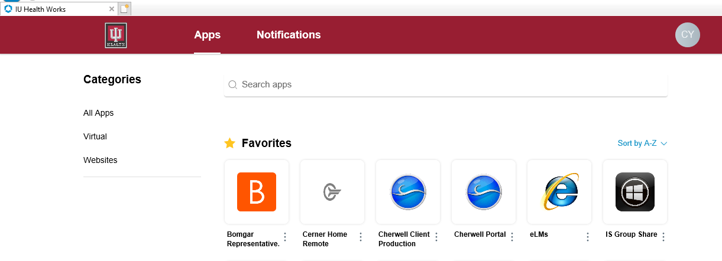

- Click on the PowerChart PROD icon.

Resources

IU Health research related education and training materials, applicable policies and procedures, and links can be found on the Office of Clinical Research Website at https://ocr.iu.edu/.

Scroll down to the “IU Health Research Information” Quick Link.

Resources include:
- Basic PowerChart Reference Guide
- Clinical Research Identification FAQ
- Accessing Apps on IU Health’s Works Web Interface
- Works Web FAQ
- Resources for DUO authentication procedures
- Research Recruitment/Opt Out Procedures
- Haystack FAQ
- Clinical Research Identification FAQ
- OnCore-PowerTrials Overview
- Clinical Research Identification
- Research Viewpoint

The IU Health Research Access Team can be contacted via e-mail at IUHealthResearchAccess@iuhealth.org.

