Topic: Accessing the Cerner EMR for Research Monitors  Facility: All IU Health Locations  Audience: Research Coordinators and Research Monitors |  | Effective Date  October 21, 2019  Contact  IUHealthResearchAccess@iuhealth.org
Overview: | This job aid outlines the steps to take for all research monitor access requests and provides instructions for utilizing Research Viewpoint in PowerChart for protocol specific EMR access.

Sponsors of clinical research often require study sites to participate in an audit of source documentation (patient records.) This activity is usually performed by independent monitors who do not have direct affiliation with the study site. To help facilitate monitor review of research pertinent information within the electronic medical record, IU Health will begin using a dynamic patient list created off the PowerTrials enrollment of a patient. PowerTrials security configuration allows a view only monitor workflow that restricts access to only the patient charts of patients enrolled on the protocol to be monitored.

Research coordinators will need to sync the subject enrollment in OnCore with the patients listed in PowerChart’s Research Viewpoint before the monitor presents for the monitoring visit.

REQUESTING ACCESS

- Research staff responsible for the protocol to be monitored begin the request process by completing the REDCap survey found at the following link- https://redcap.uits.iu.edu/surveys/?s=X837WXEF7R. You will need the full name and e-mail address of the monitor as well as the OnCore protocol number(s) to complete this survey. This link can also be used to request access to additional protocols if monitors already have Cerner access.
- The survey is automatically forwarded to the monitor to complete additional demographic information and sign the data security agreement.
- Once approved, the monitor is added to the Lawson system and access is provisioned to Cerner.
- The monitor will receive an e-mail from the CRS team with the following-
  - Key Research Policies
  - Research Monitor Job Aid
  - NT/Cerner user name and temporary password
  - Links for accessing the mandatory education modules (The monitor will have 14 days to complete the mandatory on-line training and confirm training using the REDCap survey provided with the module links.)
- The research coordinator will receive the same information with the exception of the temporary password for the monitor.

ACCESSING CERNER

Works Web is the IU Health web interface provided for launching streamed applications such as Cerner via Citrix and Horizon. It is accessible both on-site and remotely.

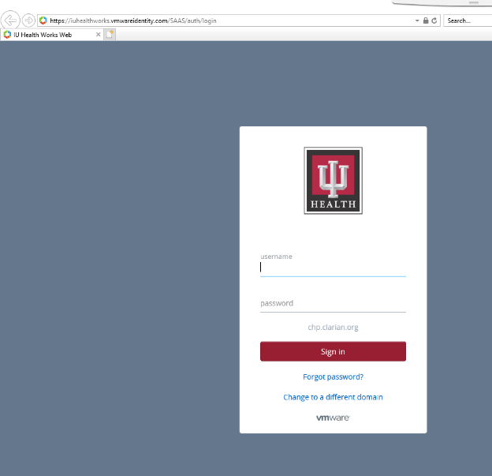
- Navigate to https://works.iuhealth.org in your internet browser.

- Sign in using your IU Health user name and password.

- Perform Duo authentication.

- Click on Cerner Home Remote icon from your Favorites folder.
(This may take a few moments to open.)

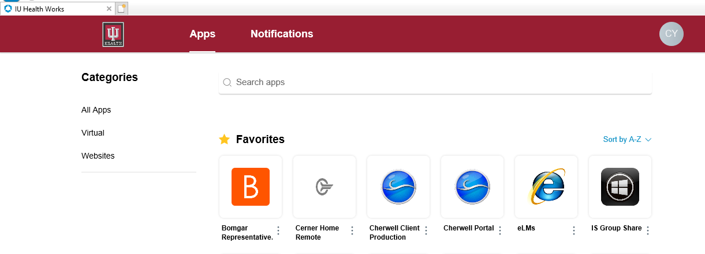
- Click on the PowerChart PROD icon.

USING RESEARCH VIEWPOINT IN POWERCHART

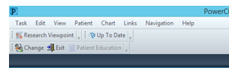
Once in PowerChart, click on Research Viewpoint in the menu bar. If it does not show up on the bar, you can select it off the “View” dropdown menu. If you have been granted access to protocols, they can be seen in the window under “Protocol Mnemonic”.

Click on the protocol listed in Research Viewpoint to open the window. Select the “Enrolled Patients” tab.

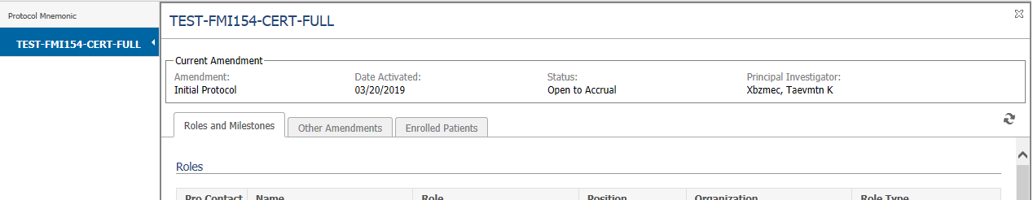

Select the study subject by clicking on the hyperlinked name.

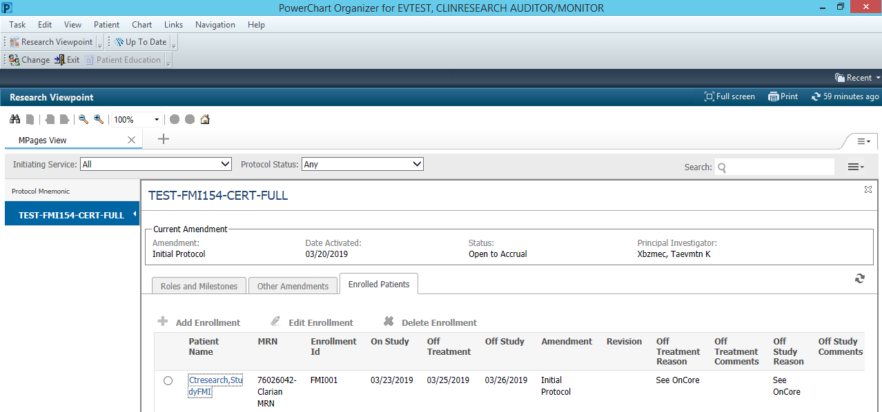

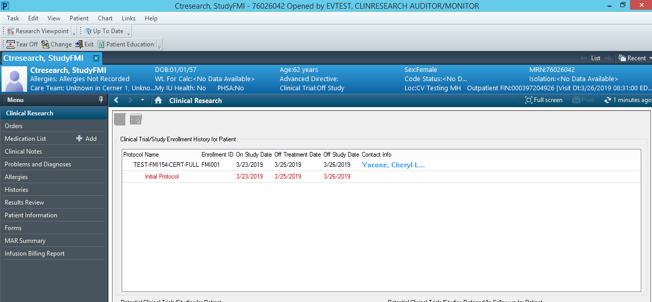

Using the menu on the left hand part of the screen, monitors will be able to access:

- Orders | - Allergies | - Forms
- Medication Lists | - Histories | - MAR Summary
- Clinical Notes | - Results Review | - Infusion Billing Report
- Problems and Diagnoses | - Patient Information

Click on Research Viewpoint in the menu to return to the patient list.

Resources

IU Health research related education and training materials, applicable policies and procedures, and links to can be found on the Office of Clinical Research Website at https://ocr.iu.edu/. Scroll down to the Quick Links “IU Health Research Information” link.

RESEARCH MONITOR PROCESS QUESTIONS/SUPPORT

Cheryl Yacone RN, BSN
Senior Clinical Systems Analyst
IU Health Research Access Team
Clinical Research Systems
317.963.0545
cyacone@iuhealth.org
iuhealthresearchaccess@iuhealth.org

**For help with DUO, Works Web, Citrix, or other access issues, please contact the IU Health Help Desk at 317.962.2828.**

