Topic: Accessing the Cerner EMR for Research Monitors  Facility: All IU Health Locations  Audience: Research Staff |  | Effective Date  Current Functionality  Contact  IUHealthResearchAccess@iuhealth.org
Overview: | This job aid outlines the steps to take for all research monitor access requests and provides instructions for utilizing Research Viewpoint in PowerChart for protocol specific EMR access.

To help facilitate monitor review of research source documentation within the electronic medical record, IU Health uses a dynamic patient list created off the PowerTrials enrollment of a subject. PowerTrials security configuration restricts access to view only for patients enrolled on the protocol to be monitored. Other patient lists will not be accessible by monitors after March 1, 2020.

REQUESTING ACCESS FOR YOUR MONITOR

- Research staff responsible for the protocol to be monitored begin the request process by completing the REDCap survey found at the following link- https://redcap.uits.iu.edu/surveys/?s=X837WXEF7R. You will need the full name and e-mail address of the monitor as well as the OnCore protocol number(s) to complete this survey. This link can also be used to request access to additional protocols if monitors already have Cerner access.
- The survey is reviewed and forwarded to the monitor to complete additional demographic information and sign the data security agreement.
- Once approved, the monitor is added to the Lawson system and access is provisioned to Cerner and will receive an e-mail from the IU Health Research Access team with information needed to access the IU Health system.
- The research coordinator will receive a copy of the same e-mail which serves as your notification that access has been granted.

ACCESSING CERNER

Monitors use the Works Web IU Health interface for accessing Cerner PowerChart via Citrix and/or Horizon. It is accessible both on-site and remotely if the IRB approved protocol allows remote access. They will be required to use IU Health DUO for multi-factor authentication. Please note that if the monitor is utilizing an IU computer for access, you will need to obtain access for them to the IU network separately.

USING RESEARCH VIEWPOINT IN POWERCHART

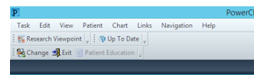
Once in PowerChart, monitors use Research Viewpoint to access the list of enrolled subjects. If Research Viewpoint is not available on the task bar as shown below, it can be selected from the “View” dropdown on the task bar.

If the monitor can’t see their protocol in the window, they may need to select “All” for Initiating Service and “Any” for Protocol Status in order to display the protocol.
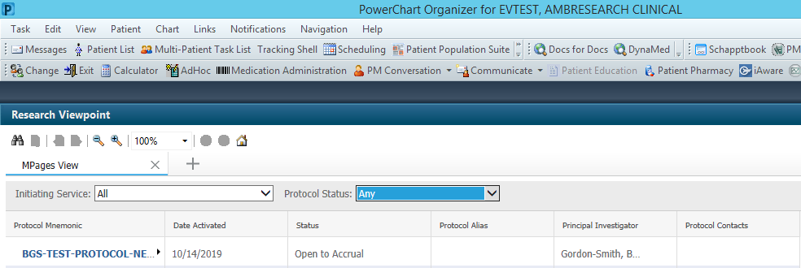

Clicking on the protocol listed in Research Viewpoint opens the window where the monitor can select the “Enrolled Patients” tab. The chart is opened by clicking on the hyperlinked name.

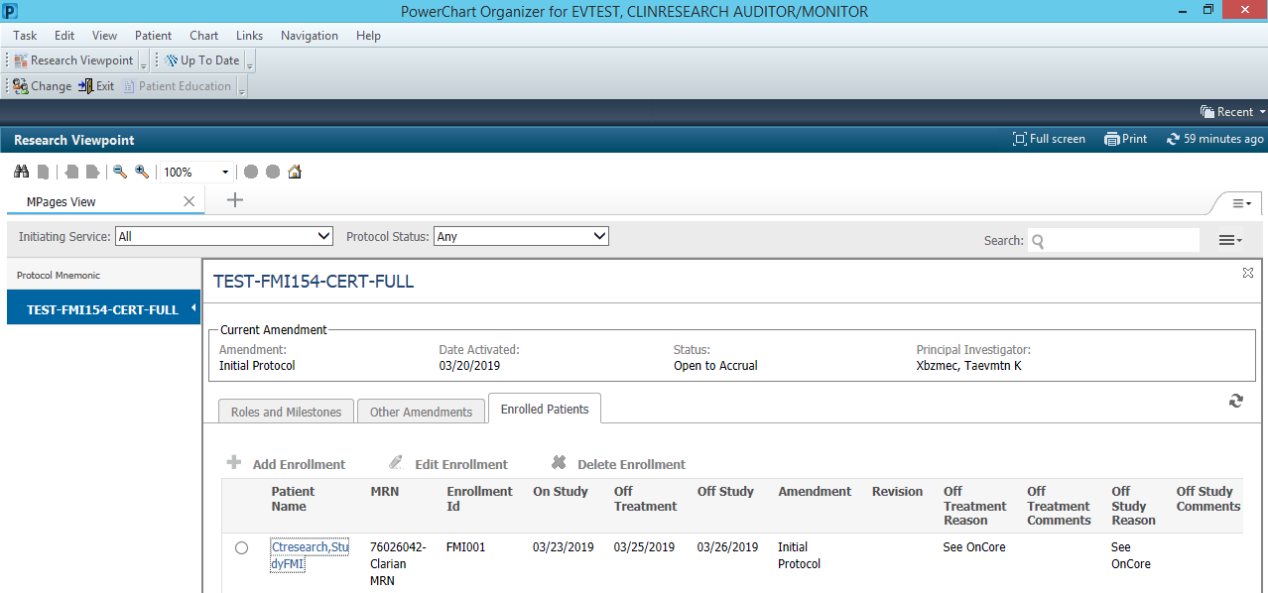
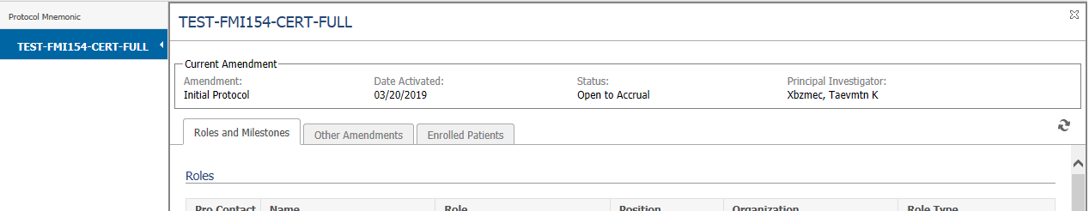

Using the menu on the left hand part of the screen in PowerChart, monitors will be able to access:

- Orders | - Allergies | - Forms
- Medication Lists | - Histories | - MAR Summary
- Clinical Notes | - Results Review | - Infusion Billing Report
- Problems and Diagnoses | - Patient Information

WHAT IF THE MONITOR CAN’T SEE ALL THE SUBJECTS?

When subjects are put in the On Study status in OnCore with a sequence no., they cross immediately from OnCore to PowerTrials as long as the protocol is open to accrual in both OnCore and PowerTrials and the subjects can be matched in Cerner with the following 3 criteria-
  - Medical Record Number
  - Last Name
  - Date of Birth
As long as the subject has been On Study in OnCore, they should be on the enrolled subjects list in Research Viewpoint. Subjects who screen fail will not be available in Research Viewpoint at this time. You will need to provide paper copies of source documentation to the monitor if needed. If the subject was On Study at any point and is not seen in Research Viewpoint, they may have failed to cross from OnCore to PowerTrials.

The following steps outline the process for resolving discrepant subjects.

- Go to the RPE Console in OnCore. (Menu-Admin-Other Admin-RPE Console)
- Click on Protocols. Enter protocol no. in filters. (Make sure other filters are empty.)
- Select Search. The protocol should show up in the RPE Eligible Protocols section near the bottom of the window. If you see the yellow triangle and a red number in the Discrepant Subjects field, one of your subjects failed to cross and needs to be reviewed. Important Note: Only 3 statuses actually cross to PowerTrials: On Study, Off Treatment and Off Study. Subjects who have failed to cross to Cerner will ONLY show up as discrepant when in one of these 3 statuses in OnCore.
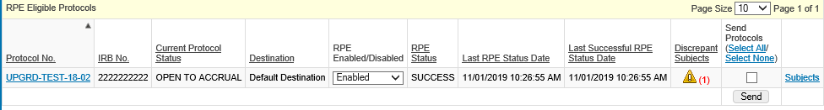

- Click on the Subjects hyperlink to see a list of subjects and their RPE transaction history.
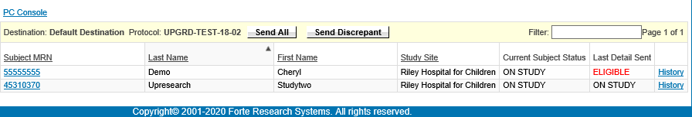

- Click on the History hyperlink at the end of the line with statuses that do not match. This will show you where the failure is and clicking on the Failure hyperlink will open up a message box that explains the problem. In this case, the MRN does not match what Cerner has. You will need to review Cerner and correct OnCore.

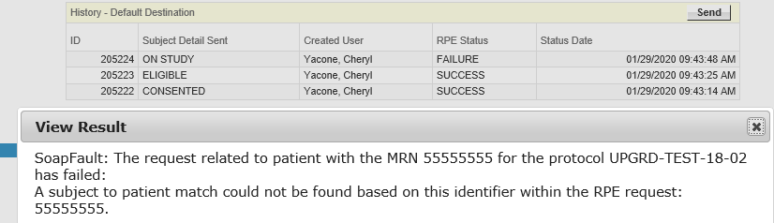

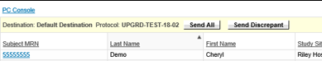
- Most corrections will cross automatically to Cerner. There is a Send All or Send Discrepant button available in the Subjects section if needed.

- If you do not see any discrepant subjects, but still do not have all the subjects in PowerTrials, it is probably because the subject is curently in one of the subject statuses that do not cross to PowerTrials. You will need to reach out to the IU Health Research Access team for assistance.

Removing monitor access

If your monitor no longer needs access either because the study is closed or he/she are no longer responsible for monitoring your study, please e-mail iuhealthresearchaccess@iuhealth.org to have the access removed.

Resources

IU Health research related education and training materials, applicable policies and procedures, and links to can be found on the Office of Clinical Research Website at https://ocr.iu.edu/. Scroll down to the Quick Links “IU Health Research Information” link.

RESEARCH MONITOR PROCESS QUESTIONS/SUPPORT

Cheryl Yacone RN, BSN
Senior Clinical Systems Analyst
IU Health Research Access Team
Clinical Research Systems
317.963.0545
cyacone@iuhealth.org
iuhealthresearchaccess@iuhealth.org

**For help with DUO, Works Web, Citrix, or other access issues, please contact the IU Health Help Desk at 317.962.2828**

