|  |  |  |  |  |  |  |  |  |  |  |  |  |
| --- | --- | --- | --- | --- | --- | --- | --- | --- | --- | --- | --- | --- |
| |  |  | | --- | --- | | Topic: | Accessing the Cerner EMR for Research Monitors | | Facility: | All IU Health Locations | | Audience: | Research Monitors | | | |  | | --- | | Effective Date | | Current Functionality | | Contact | | ISClinicalResearchSupport@iuhealth.org | |
|  | |  |
|  | | |
| Overview: | This job aid outlines the process for monitor review of research pertinent information within the electronic medical record. IU Health provides monitor access to the EMR through a dynamic subject list created off the OnCore/PowerTrials subject enrollment on a protocol present in PowerTrials. | |

**ACCESSING CERNER**

**For issues with accessing Cerner, please contact the IU Health Help Desk- 317.962-2828**

If you are accessing remotely or from a non-IU Health computer, you will need access to the following applications to view Cerner remotely:

* Microsoft Authenticator (MS Authenticator) for multi-factor authentication
* VMware Horizon Client

Instructions for downloading and using these apps can be found on the Office of Clinical Research website at <https://ocr.iu.edu/> under the IU Health Research Info-> IU Health System Access->Remote Access section. Works best with Chrome of Firefox browser.

1. 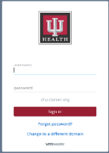Navigate to <https://works.iuhealth.org> in an internet browser.

1. Sign in using your IU Health username and password.
2. Perform authentication. If you have not set up your IU Health Microsoft Authenticator account yet, please follow the link highlighted in yellow above. Scroll down to the Cerner Remote Access section under the IU Health System Access section and find the FAQs for setting up MS authenticator and registering your device.

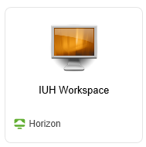

1. Click on the IUH Workspace icon to open the virtual desktop.
2. If the application does not open right away, you may not have Horizon VMware downloaded. Instructions and links to download that software can be found on the website highlighted above. You will need admin rights to your computer in order to download. If you are asked for admin credentials during the download, you will need to contact your IT department to complete the download.



1. Click on the Cerner icon on the desktop. Select the PowerChart PROD shortcut and click to open.
2. If you need to access your desktop while using the IU Health virtual desktop, you can click on the “Windowed” mode button on the toolbar to the left of the “X”. If you use multiple monitors, check out the website highlighted above for set-up instructions on using multiple monitors with a virtual desktop.



**USING RESEARCH VIEWPOINT IN POWERCHART**

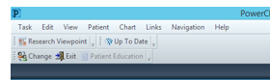Once in PowerChart, click on Research Viewpoint in the menu bar. If it does not show up on the bar, you can select it off the “View” dropdown menu. If you have been granted access to protocols, they can be seen in the window under “Protocol Mnemonic”.

**Select All Protocols for Initiating Service and Any for Protocol Status in order to display your protocol(s).**

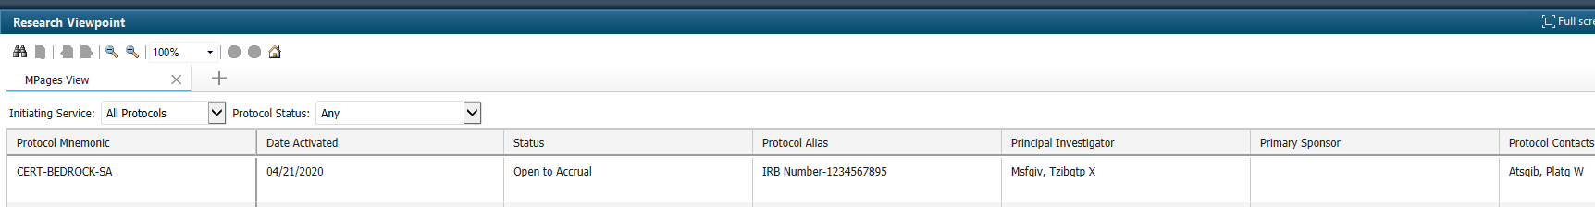

Click on the protocol listed in Research Viewpoint to open the window.

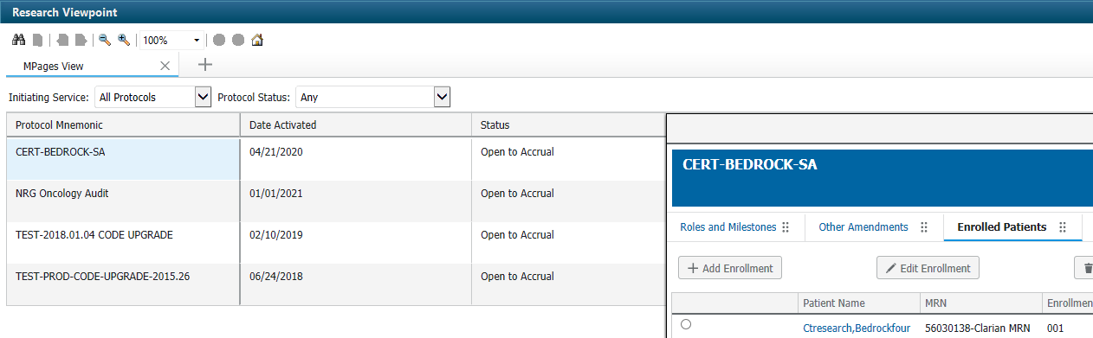

Select the “All Patients” tab.



Select the study subject by clicking on the hyperlinked name. This will open their medical record in PowerChart.

